
School of Humanities & Sciences D Y Patil Deemed to be University Navi Mumbai

Deep Learning Project Course Code: 2522MCD3P1
Course Name: Machine Learning

Submitted by

DY25SHSP0MCA159
Rutvik Suryakant Varankar

DY25SHSP0MCA125
Pranav Pramod Kamble

DY25SHSP0MCA182
Samir Nasir Shaikh

in partial fulfilment for the award of the degree
of
M.C.A. Semester II (2025-2026)

TABLE OF CONTENT

SR No | TOPIC | Page No
1 | Introduction
2 | Scope and objectives
3 | Project description
4 | Existing system
5 | Proposed system
6 | Technology used
7 | Implementation of project
8 | Screenshots of user interface or output
9 | Conclusion

- Introduction
Lung cancer is one of the major health concerns worldwide, and its early and accurate detection is essential for effective treatment and improved patient outcomes. Medical imaging techniques, particularly Computed Tomography (CT) scans, help identify abnormalities in lung tissues. However, manually analyzing these images can be complex and time-consuming. Deep learning techniques offer a promising approach to automating medical image classification. This project, “Lung Cancer Classification Using VGG16 Transfer Learning,” aims to classify lung CT scan images into three categories: Benign, Malignant, and Normal. The system uses the VGG16 convolutional neural network, pre-trained on the ImageNet dataset, to extract important image features through transfer learning. The IQ-OTH/NCCD Lung Cancer Dataset is used to train and evaluate the model. The model achieved a reported classification accuracy of 95.7% and a malignant-case sensitivity of 99%. The project also emphasizes scientific reliability by identifying and removing duplicate images shared between the training and validation sets to reduce data leakage and obtain a more reliable performance evaluation. Overall, this project demonstrates the potential of deep learning and transfer learning for automated lung CT image classification. The developed model serves as a research prototype that may support further medical image analysis research, although additional validation is necessary before clinical application.
- Scope and objectives
Scope:
The scope of this project is to develop a deep learning-based system for classifying lung CT scan images into three categories: Benign, Malignant, and Normal. The system uses VGG16 transfer learning and the IQ-OTH/NCCD Lung Cancer Dataset to identify relevant image features and predict the corresponding class. The project includes image preprocessing, model training, validation, performance evaluation, and visualization of results using metrics such as accuracy, sensitivity, and a confusion matrix. It also focuses on preventing data leakage by identifying and removing duplicate images from the training and validation sets. The system is intended for academic research and experimental medical image classification. Future improvements may include Grad-CAM visualizations for model interpretability and deployment through a web application. The model is not intended to replace professional medical diagnosis.

Objective:
The main objectives of the project are:
- To develop a classification model: Build a deep learning system to classify lung CT scan images into Benign, Malignant, and Normal categories.
- To implement transfer learning: Utilize the pre-trained VGG16 architecture to extract meaningful image features and improve classification performance.
- To preprocess the dataset: Prepare and organize images from the IQ-OTH/NCCD Lung Cancer Dataset for model training and evaluation.
- To prevent data leakage: Identify and remove duplicate images shared between the training and validation datasets to improve evaluation reliability.
- To evaluate model performance: Measure classification accuracy, malignant-case sensitivity, and other relevant metrics using a confusion matrix and evaluation reports.
- To visualize training results: Analyze training and validation accuracy and loss curves to understand model performance and identify potential overfitting.
- Project Description
The project implements a deep learning pipeline for classifying lung CT scan images using VGG16 transfer learning. Developed using Python, TensorFlow, and Keras, the system incorporates image preprocessing, model training, validation, and performance evaluation using the IQ-OTH/NCCD Lung Cancer Dataset. The classification task involves three categories: Benign, Malignant, and Normal. During experimentation, an initial custom Convolutional Neural Network (CNN) achieved approximately 45% accuracy, leading to the adoption of VGG16 with pre-trained ImageNet weights to improve feature extraction and classification performance. A dataset audit identified 43 duplicate images across the training and validation sets, which were removed to address data leakage and improve evaluation reliability. The final model achieved a reported accuracy of 95.7%, correctly identifying 101 out of 102 malignant cases in the evaluated sample. Model performance was assessed using classification accuracy, malignant-case sensitivity, confusion matrices, and training and validation curves. The project emphasizes the importance of transfer learning, systematic experimentation, and proper dataset preparation in developing reliable deep learning models for medical image classification.
- Existing system
Traditional lung cancer classification methods primarily rely on radiologists and medical professionals to examine CT scan images and identify abnormalities. Although these methods are essential for diagnosis, manual interpretation can be time-consuming and may vary depending on the experience of the specialist and the complexity of the images. Identifying subtle differences between benign, malignant, and normal lung tissues can also be challenging. Some existing automated systems use conventional image processing techniques and machine learning algorithms that depend on manually extracted features, such as texture, shape, and intensity. However, these approaches may struggle to identify complex patterns and subtle variations in lung CT images, potentially affecting classification performance. Basic Convolutional Neural Networks (CNNs) also require sufficient training data and careful parameter tuning to achieve reliable results. Furthermore, improper dataset preparation, particularly the presence of duplicate images across training and validation sets, can lead to data leakage and misleadingly high accuracy. These limitations highlight the need for improved deep learning approaches that provide effective feature extraction, reliable classification, and rigorous model evaluation.
- Proposed system
The proposed system aims to develop an automated lung cancer classification model using deep learning and VGG16 transfer learning. Unlike traditional approaches that rely heavily on manual image interpretation or handcrafted features, the system automatically learns relevant patterns from lung CT scan images to classify them into three categories: Benign, Malignant, and Normal. The IQ-OTH/NCCD Lung Cancer Dataset is used for model development and evaluation. The process begins with image preprocessing, where CT scan images are prepared in a consistent format suitable for the VGG16 architecture. The pre-trained VGG16 model, originally trained on the ImageNet dataset, is adapted to the lung cancer classification task through transfer learning. The extracted image features are used to train the classification model to distinguish between the three categories. Model performance is evaluated using accuracy, sensitivity, a confusion matrix, and training and validation curves.
To improve the reliability of the results, the dataset is examined for duplicate images across the training and validation sets. During this process, 43 duplicate images were identified and removed to address data leakage. Following this correction, the model achieved a reported classification accuracy of 95.7% and correctly identified 101 out of 102 malignant cases in the evaluated sample. Overall, the proposed system provides an automated and systematic approach to lung CT scan classification, emphasizing effective feature extraction, classification performance, and reliable model evaluation. It is intended for research purposes and does not replace professional medical diagnosis.

- Technology used

- Programming Language:
  - Python

- Libraries:
- Pathlib – Used to manage file and directory paths and access dataset images efficiently.
- NumPy – Used for numerical computations and manipulation of image arrays and numerical data.
- Matplotlib – Used to visualize training accuracy, loss curves, and model performance.
- Seaborn – Used to create statistical visualizations, including confusion matrix heatmaps.
- Tensorflow – Used to build, train, and evaluate the VGG16-based deep learning classification model.
- Os – Used to interact with the operating system, access directories, and organize dataset files.

- Techniques:
- Transfer Learning – Utilizes the pre-trained VGG16 model to extract relevant features from lung CT scan images and improve classification performance.
- Convolutional Neural Network (CNN) – Learns spatial features and visual patterns from CT scan images to distinguish between different lung conditions.
- Image Preprocessing – Resizes and normalizes CT scan images into a consistent format suitable for model training and evaluation.
- Multi – Class Image Classification – Classifies lung CT scan images into three categories: Benign, Malignant, and Normal.

- Framework and API:
- Flask – for developing the web based frontend
- Keras – An open-source deep learning API used to build, train, and evaluate neural network models efficiently.
- Tools/Environment:
- Jupyter Notebook / VS Code (for development and testing)

- Implementation of project (code file name followed by code)
Model.ipynb

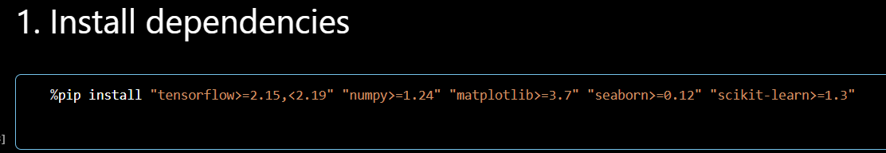

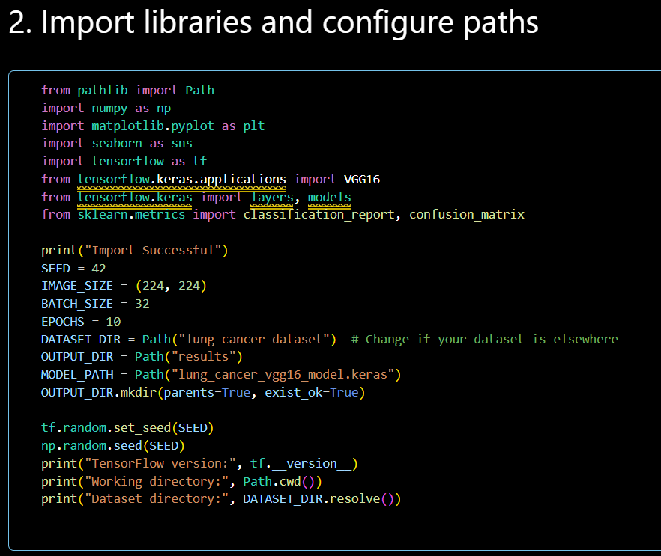
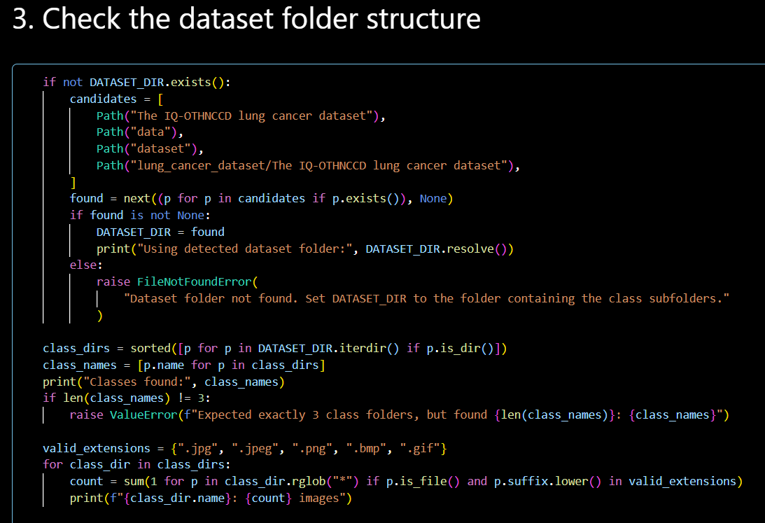

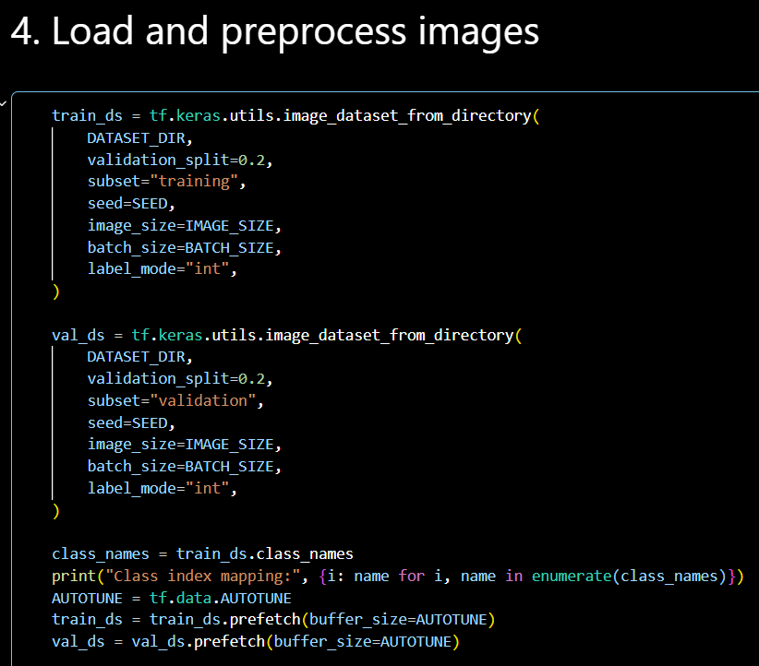

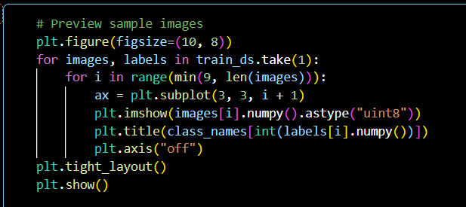
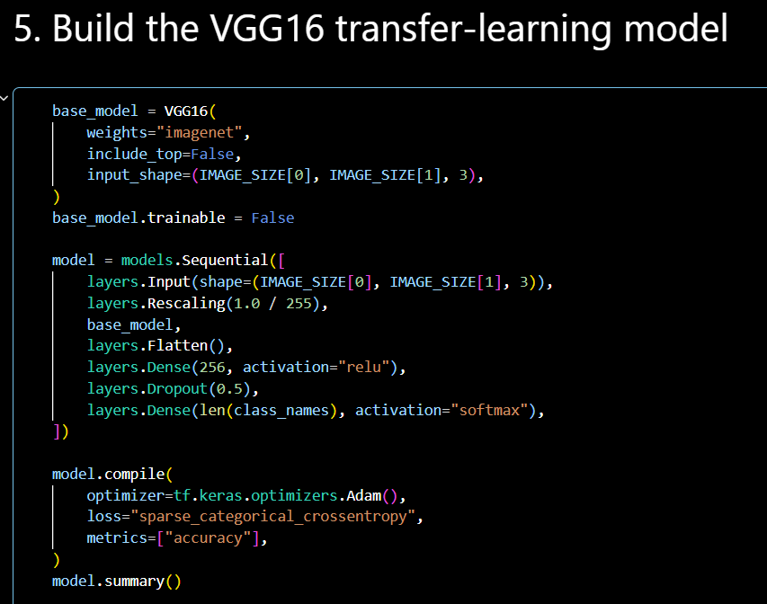

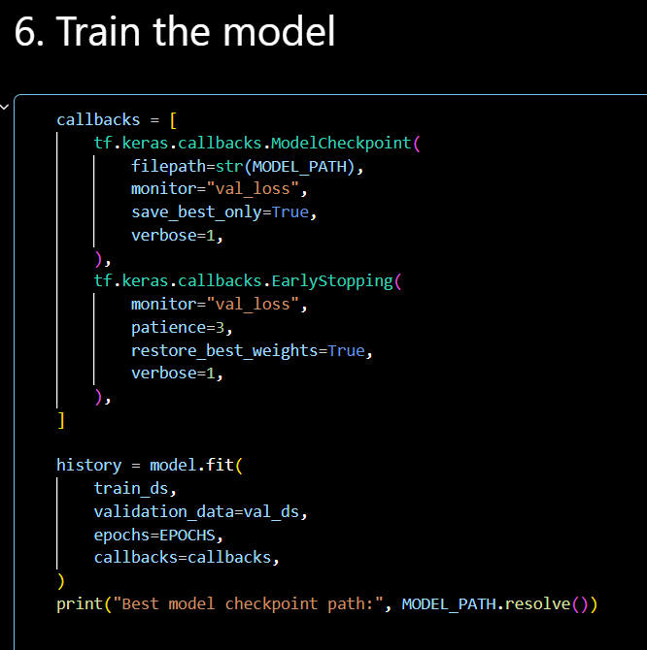

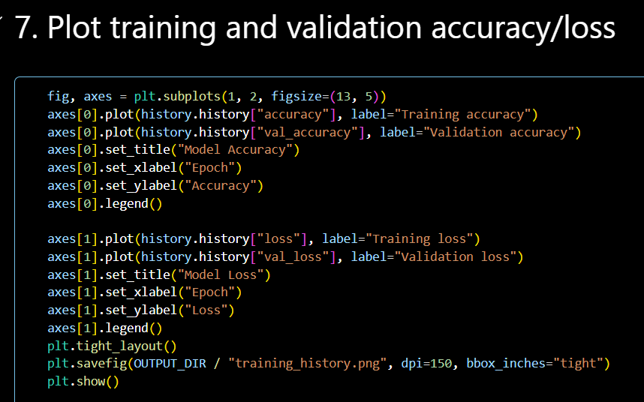

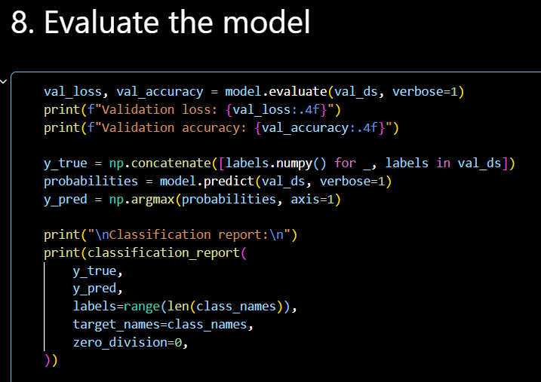

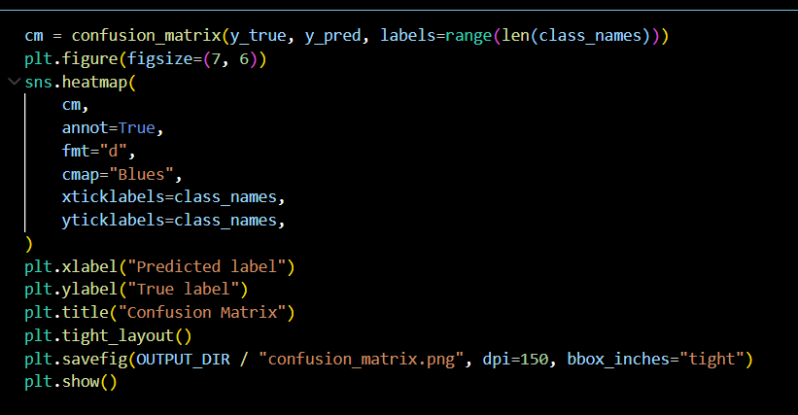
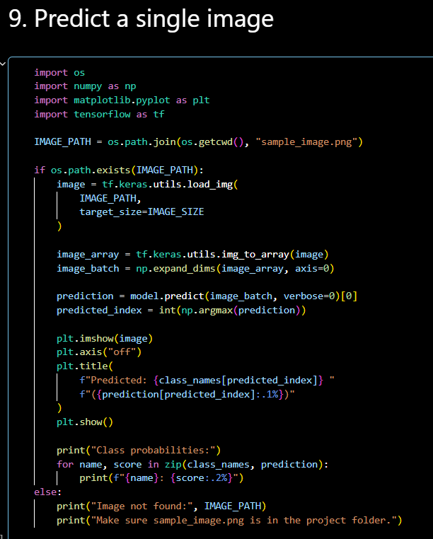

app.py

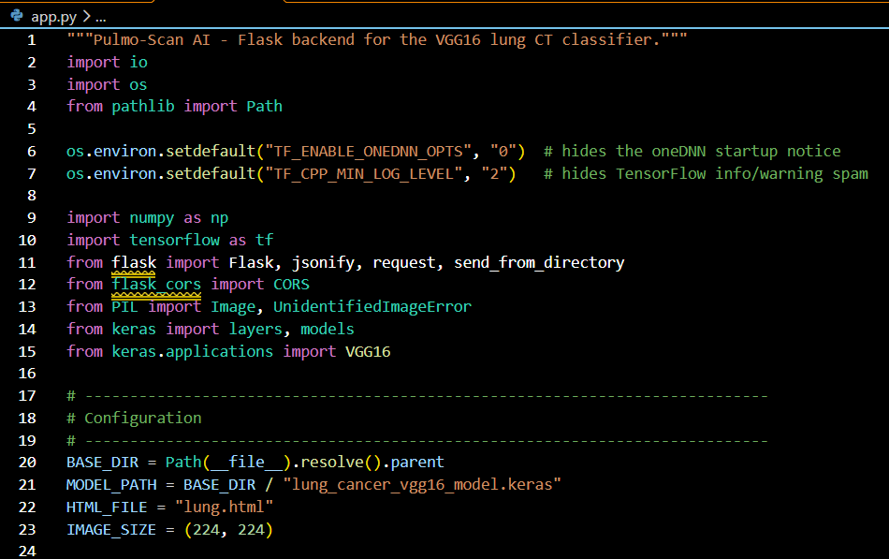
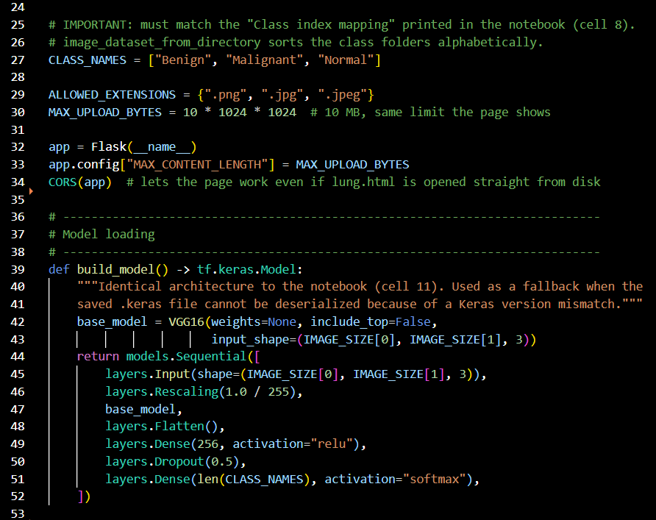

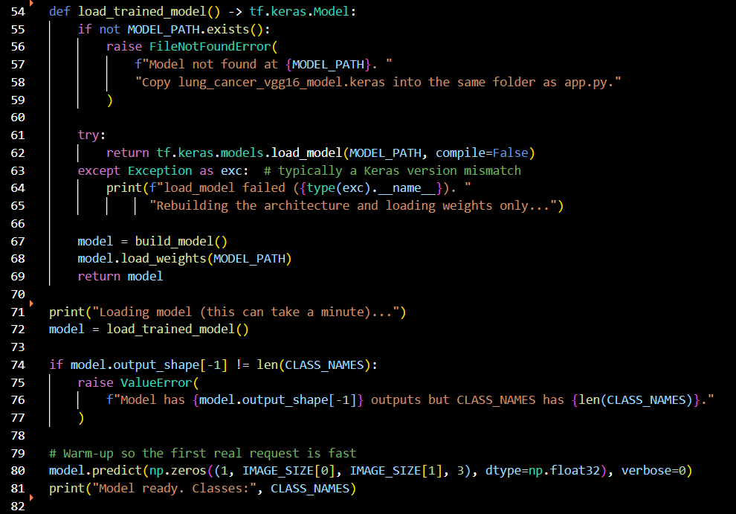
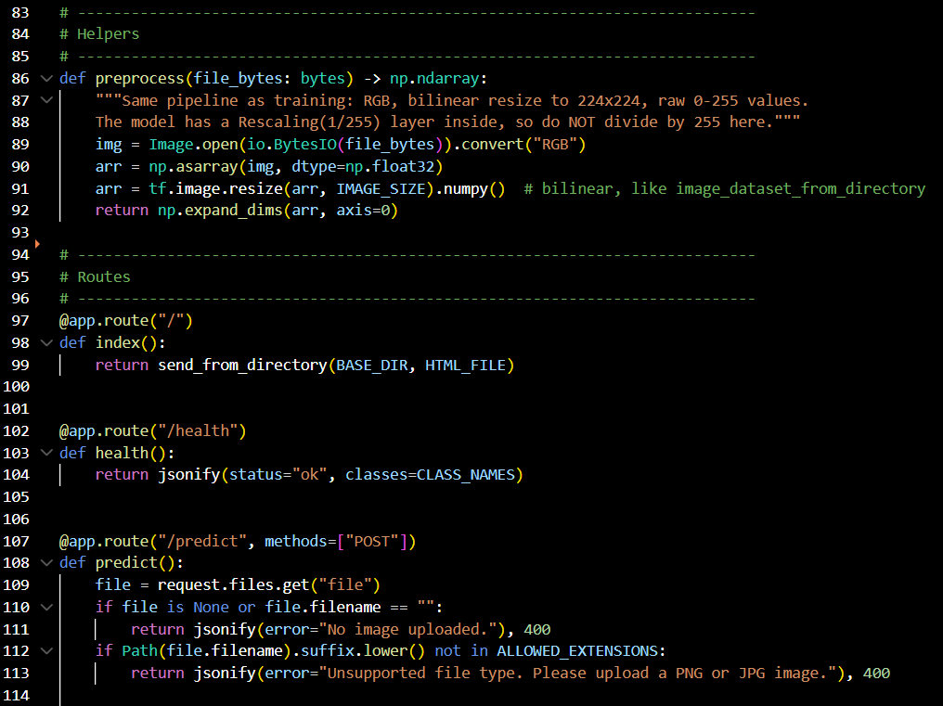

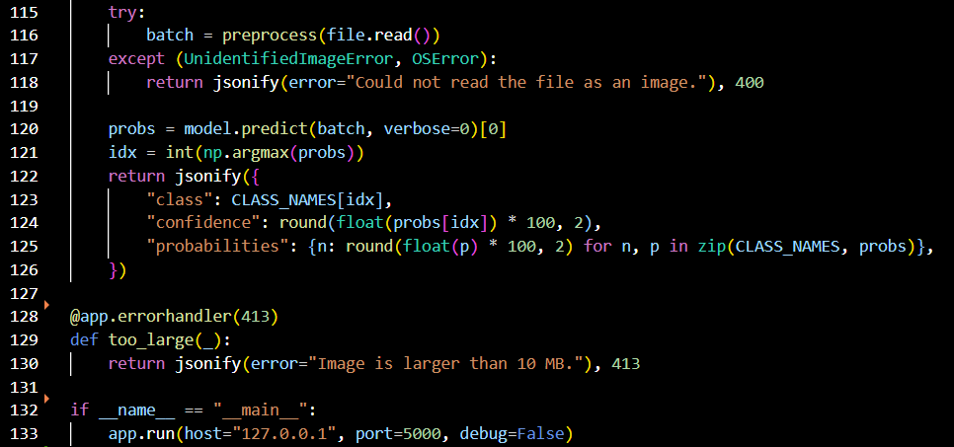

- Screenshots of user interface or output

- Conclusion
The Lung Cancer Classification project successfully demonstrates the application of deep learning and transfer learning for classifying lung CT scan images into three categories: Benign, Malignant, and Normal. By utilizing the VGG16 architecture and the IQ-OTH/NCCD Lung Cancer Dataset, the system learns relevant image features and achieves a reported classification accuracy of 95.7%, with 99% sensitivity for malignant cases. An important contribution of the project is its focus on data integrity and reliable model evaluation. During development, 43 duplicate images were identified across the training and validation sets and removed to address data leakage. The model's performance was evaluated using accuracy, sensitivity, confusion matrices, and training and validation curves to assess its classification capability. Overall, the project highlights the effectiveness of transfer learning in medical image classification and emphasizes the importance of proper data preprocessing and evaluation practices. The developed system serves as a research prototype for automated lung CT scan classification. However, further validation using independent patient data is necessary before its results can be considered suitable for clinical use.

